Emilio HIRSCH, PhD
Dipartimento di biotecnologie molecolari e scienze della vita, Università di Torino. I-10126 Torino, Italy
Phone: +39-011 670 6425; Fax: +39-011-670 6432; E-mail: emilio.hirsch@unito.it

Born in Torino, Italy, July 22nd, 1965; Married and with two daughters.
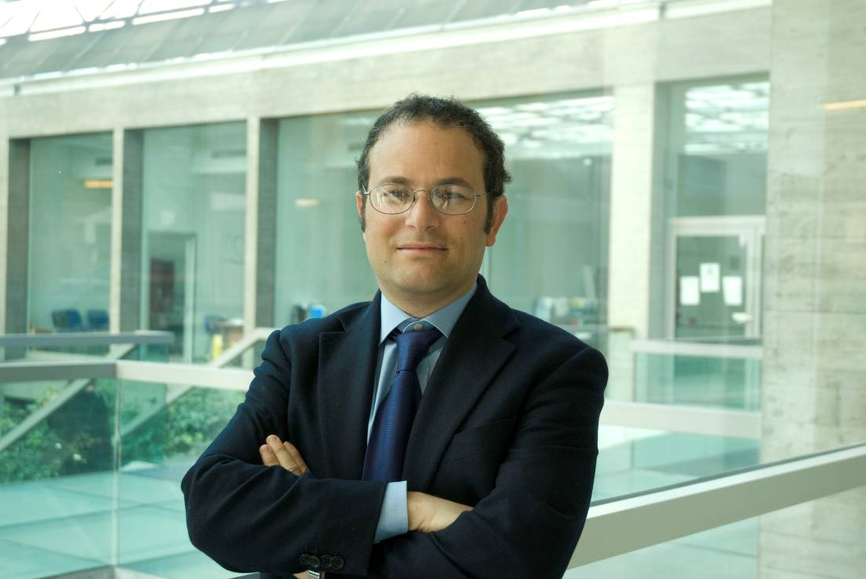

Emilio HIRSCH is Professor of Experimental Biology at the Medical School of the University of Torino. He is author of 227 publications, his works received around 17000 citations and his h-index (Google Scholar) is 71. EMBO and FISHR member.
He provided seminal contributions in the characterization of phosphoinositide 3-kinases (PI3K) as drug targets in inflammation (Science 2000, Immunity 2002), cancer (Science Signaling 2008, Cancer Cell 2011 and 2014), heart failure (Cell 2004, Molecular Cell 2011, Circulation 2011 and 2012), and obesity (Science Signaling 2014). He produced the first knockout mice for a PI3K catalytic subunit and demonstrated the role of PI3Kgamma in chemotaxis of leukocytes (Science 2000; PNAS 2007, Blood 2012). He collaborated with Merck-Serono in the characterization of the first isoform selective PI3Kgamma inhibitor (Nat Med 2005) and launched an academic spin off (Kither Biotech srl) exploiting his patented PI3K inhibitors for topical treatment. He was the first to demonstrate that PI3K are not only enzymes but also scaffold proteins (Cell 2004, Mol Cell 2011), showing that knock-in of a catalytically inactive mutant better models drug targeting than knock-out-mediated elimination of the protein. He demonstrated that PI3Kbeta has scaffold functions (Sci Signal 2008) and that PI3Kgamma associates with PKA to integrate PI3K and cAMP signaling (Cell 2004; Mol Cell 2011; Circulation 2012). More recently, he shifted his attention to class II PI3Ks and defined the role of PI3KC2alpha in endocytosis (Nature 2013) and primary cilium function (Dev Cell 2014; JASN 2015; Nat Com 2015). His work on the role of PI3KC2alpha in breast cancer opened a new way to precisely predict sensitivity to Taxane-based therapies, a mainstay in treatment but with so far variable and erratic efficacy (Gulluni et al., Cancer Cell, 2017).

Education:
1988 Graduation in Biology in the University of Torino (110 cum laude)
1994 Ph.D (Dottorato di Ricerca "Biologia Umana: Basi Molecolari e Cellulari [V ciclo]") -Mentor: Prof. Lorenzo Silengo, Università degli studi di Torino.

Professional Service:
1995-1996 Postdoctoral Fellow in Prof. Reinhard Fässler lab (Max-Planck Institute for Biochemistry; Martinsried -Munich - Germany).
1995-2000 Assistant Professor, University of Torino, Medical Faculty, Dip.to Genetica, Biologia e Biochimica
2000-2005 Associate Professor, University of Torino, Medical Faculty, Dip.to Genetica, Biologia e Biochimica
2005-present Full Professor of Biology, Univ. Torino. Medical Faculty, Dipto Genetica, Biologia e Biochimica
2006-2012 Member of the Translational Research Committee of the Heart Failure Association of the European Society of Cardiology
2007-2010 Scientific Advisory Board member, Celzome AG, Germany
2005-2009 Consultant for Serono and Merck-Serono
2005-2011 School of Medicine of Torino, Vice-president
2013-2016 Review panel member for AERES Evaluation Committee for the INSERM-University Pierre et Marie-Curie Unit project (France): Cardiovascular Diseases and Metabolism
2011-2016 Member of the Directive Nucleus of the Working Group of Myocardial Function of the European Society of Cardiology
2011-2015 Member of the ISHR (International society for Heart Research) European Council

Selected Grants and Awards:
2000-2002 Human Frontier Science Project grant.
2002 Costa Award for Molecular Biology
2001-2003 European Union Grant (FP-5) QLG1-CT-2001-02171
2005 Descartes Prize for Collaborative Research – European Union Framework Fifth – Finalist (2° Prize)
2006 European Union Grant (FP-6) EUGeneheart 18833
2007 Leducq Foundation Grant CycAMP
2010 Leducq Foundation Grant Nitrosoredox
2011 Member of the ISHR (International society for Heart Research) Council
2012 5th Annual Landon Foundation-AACR INNOVATOR Award
2015 EMBO member
2015 Fellow of the ISHR (FISHR)

Spin-off participation
Co-founder of Kither Biotech SrL, a product company launched in 2013 and focusing on drug discovery. The company is based on the IP outlined below and develops drugs for untreatable respiratory diseases like idiopathic pulmonary fibrosis and cystic fibrosis. One of its compounds received the orphan drug designation by EMA in 2017.

Selected Patents
- WO_2008/099280_A2 (mammary gland model of PI3Kβ action; approved in EU and USA)
- WO/2012/073184 (Pan class I PI3K inhibitor; approved in USA)
- TO2014A000264 (Rab11 activity probe; pending)
- WO/2009/147486
- WO/2005/084696
- TO2014A001105 (A peptide-based treatment for cystic fibrosis).

Ten selected peer-reviewed publications (2004-2016):
- Patrucco E., Notte A., Barberis L., Selvetella G., Maffei A., Brancaccio M., Marengo S., Russo G., Azzolino O., Rybalkin S., Silengo L., Altruda F., Wetzker R., Wymann M., Lembo G., Hirsch E.
PI3Kγ modulates the cardiac response to chronic pressure overload by distinct kinase-dependent and independent effects.
Cell. 118 : 375-387 (2004).
- Camps M., Ruckle T., Ji H., Ardissone V., Rintelen F., Shaw J., Ferrandi C., Chabert C., Gillieron C., Francon B., Martin T., Gretener D., Perrin D., Leroy D., Vitte P.A., Hirsch E., Wymann M.P., Cirillo R., Schwarz M.K., Rommel C.
Blockade of PI3Kgamma suppresses joint inflammation and damage in mouse models of rheumatoid arthritis.
Nature Medicine.11:936-943. (2005).
- Perino A, Ghigo A, Ferrero E, Morello F, Santulli S, Baillie GS, Damilano F, Dunlop AJ, Pawson C, Walser R, Levi R, Altruda F, Silengo L, Langeberg LK, Neubauer G, Heymans S, Lembo G, Wymann MP, Wetzker R, Houslay MD, Iaccarino G, Scott JD, Hirsch E.
Integrating cardiac PIP3 and cAMP signaling through a PKA anchoring function of p110γ.
Mol Cell. 42:84-95. (2011).
- Damilano F., Franco I., Perrino C., Schaefer K., Azzolino O., Carnevale D., Cifelli G., Carullo P., Ragona R., Ghigo A., Perino A., Lembo G., Hirsch E.
Distinct effects of leukocyte and cardiac phosphoinositide 3-kinase γ activity in pressure overload-induced cardiac failure.
Circulation. 123:391-9. (2011)
- Posor Y., Eichhorn-Gruenig M., Puchkov D., Schöneberg J., Ullrich A., Lampe A., Müller R., Zarbakhsh S., Gulluni F., Hirsch E., Krauss M., Schultz C., Schmoranzer J., Noé F., Haucke V.
Spatiotemporal control of endocytosis by phosphatidylinositol-3,4-bisphosphate
Nature. 499:233-7. (2013).
- Franco I., Gulluni F., Campa C. C., Costa C., Margaria J. P., Ciraolo E., Martini M., Monteyne D., De Luca E., Germena G., Posor Y., Maffucci T., Marengo S., Haucke V., Falasca M., Perez-Morga D., Boletta A., Merlo G. R., Hirsch E.
PI3K class II α controls spatially restricted endosomal PtdIns3P and Rab11 activation to promote primary cilium function.
Dev Cell. 28:647-58. (2014)
- Hirsch E., Novelli F.
Cancer: natural-born killers unleashed.
Nature. 510:342-3. (2014)
- Braccini, L., Ciraolo, E., Campa, C.C., Perino, A., Longo, D.L., Tibolla, G., Pregnolato, M., Cao, Y., Tassone, B., Damilano, F., Laffargue, M., Calautti, E., Falasca, M., Norata, G.D., Backer, J.M. and Hirsch, E.
PI3K-C2gamma is a Rab5 effector selectively controlling endosomal Akt2 activation downstream of insulin signalling.
Nature Communications. 6:7400 (2015)
- Gulluni F, Martini M, De Santis MC, Campa CC, Ghigo A, Margaria JP, Ciraolo E, Franco I, Ala U, Annaratone L, Disalvatore D, Bertalot G, Viale G, Noatynska A, Compagno M, Sigismund S, Montemurro F, Thelen M, Fan F, Meraldi P, Marchiò C, Pece S, Sapino A, Chiarle R, Di Fiore PP, and Hirsch E.
Mitotic spindle assembly and genomic stability in breast cancer require PI3K-C2α scaffolding function.
Cancer Cell. 32:444-459 (2017)
- Li M, Sala V, De Santis MC, Cimino J, Cappello P, Pianca N, Di Bona A, Margaria JP, Martini M, Lazzarini E, Pirozzi F, Rossi L, Franco I, Bornbaum J, Heger J, Rohrbach S, Perino A, Tocchetti CG, Lima BHF, Teixeira MM, Porporato PE, Schulz R, Angelini A, Sandri M, Ameri P, Sciarretta S, Lima-Júnior RCP, Mongillo M, Zaglia T, Morello F, Novelli F, Hirsch E, Ghigo A.
Phosphoinositide 3-Kinase Gamma Inhibition Protects from Anthracycline Cardiotoxicity and Reduces Tumor Growth.
Circulation. In Press. (2018)

Editorial board membership
Thrombosis and Hemostasis
Cell Communication & Signaling
American Journal of Cardiovascular Disease
Cardiovascular Research (Associate Editor 2012-2017),
Cancers
PLoSONE.

Invited presentations
58 invited lectures, 42 invitations to international meetings (including Keystone 2006, 2011, 2013; GRC 2012, 2016, 2018; Pezcoller 2009; Cold Spring Harbor 2010, 2012, 2014; EMBO workshop 2013, 2014), 3 honorary lectures (Modulatory Units in Heart Failure, Eisenach, Germany, 2014; Leukocyte adhesion, Menaggio, Italy, 2013; PI3K take the center stage, 2015, Toulouse, France).

Organizations of international conferences
“Molecular Determinants of Cell Signalling”, Torino, Italy, 25-27/6/2007, organizer with Giorgio Scita (Milano) e Stefano Alemà (Roma); “Mechanisms of Signal Transduction”, Pontignano (SI), Italy, 20-21/3/2009 organizer with Annarosa Arcangeli (Firenze); “Endocrinology meets science”, 24-26/9/2009, member of the scientific advisory board; “International workshop on signal transduction in cancer” Torino (Italy), 15-18/6/2009 organizer with Pier Paolo Pandolfi (Boston, MA, USA); “Translational Winter Research Meeting – Heart Failure Association”, Les Diablerets, Switzerland, 27-30/1/2010, member of the scientific advisory board; “SFB914 Symposium on Leukocyte Adhesion and Migration”, Menaggio, Italy, 24-27/10/2011, Organizer with Markus Sperandio (Munich, D). Member of the organizing committee of the 33rd annual meeting of the European section of the ISHR –July, 1st to 4th 2015, Bordeaux, France. Member of the local organizing Committee of FCVB 2016 Florence, Italy. Organizer of the Keystone Meeting 2018 on “Phosphoinositide Biology: New Therapeutic Targets beyond Class I PI3K”, Taos (NM) USA.

Major contributions to early careers of excellent researchers
EH has trained 72 undergraduate students, PhD students and postdocs, many of whom moved on to obtain their own independent positions in academic institutions or industry. Among the most successful: Dr. Xiao Yun Lu is Full Professor since 2012 at Jiao Tong University, China; Mara Brancaccio is Group leader and Associate Professor since 2005 at the University of Turin; Dr. Alessandra Ghigo is Assistant Professor since 2014 and tenure Associate Professor since 2016 at the University of Turin; Dr. Stefano Marengo is Technician at the University of Turin; Dr. Federico Damilano is post-doctoral fellows at Harvard Medical School; Dr. Alessia Perino is an EMBO awarded post-doctoral fellow at EPFL, Switzerland. Dr. Carlotta Costa is group leader in Novartis, Basel (CH); Dr. Laura Barberis is senior scientist at Merck Serono and Dr Michela Pozzato is working at AstraFormedic. Alessandra Ghigo is tenure track associate professor (RTDB) in the University of Torino.

Activity in technology transfer
EH consulted Serono, Cellzome AG, Infinity, Intellikine. He was member of the scientific advisory board of Cellzome AG, Heidelberg, Germany from 2009 to 2011. He is founder and shareholder of the biotechnological academic spin-off Kither Biotech SrL. Kither biotech is focused on the development of new safer and more effective drugs for local treatment in lung diseases. Kither Biotech is currently developing PI3K inhibitors for pulmonary fibrosis, severe asthma, lung cancer and cystic fibrosis. Recent negotiation with Italian and American business angels valued the asset of the company as 10 milion €. EH is also shareholder and member of the management board of Kalyera SpA, an IT company based in Milan with currently 120 employees.

Torino 25/9/2017

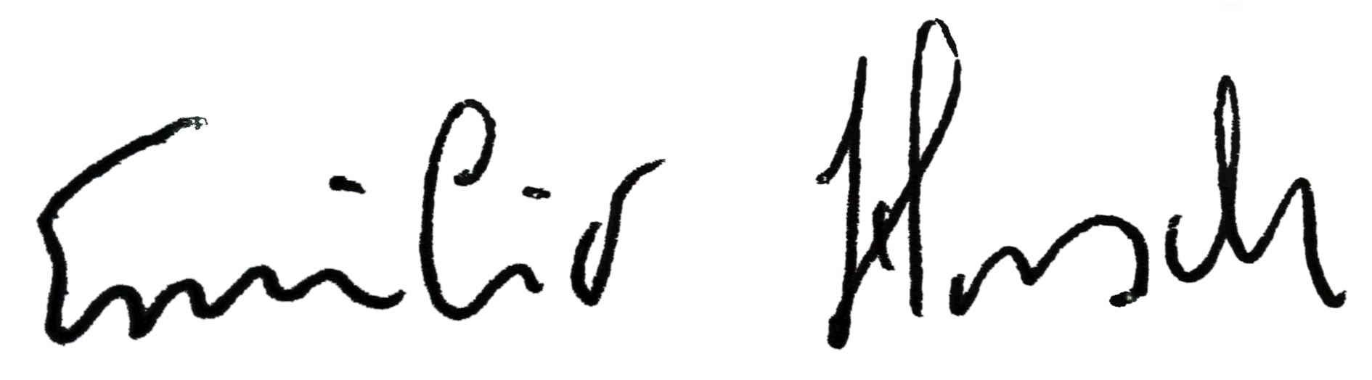
Emilio Hirsch

