CURRICULUM VITAE

Name | Paola BONFANTE 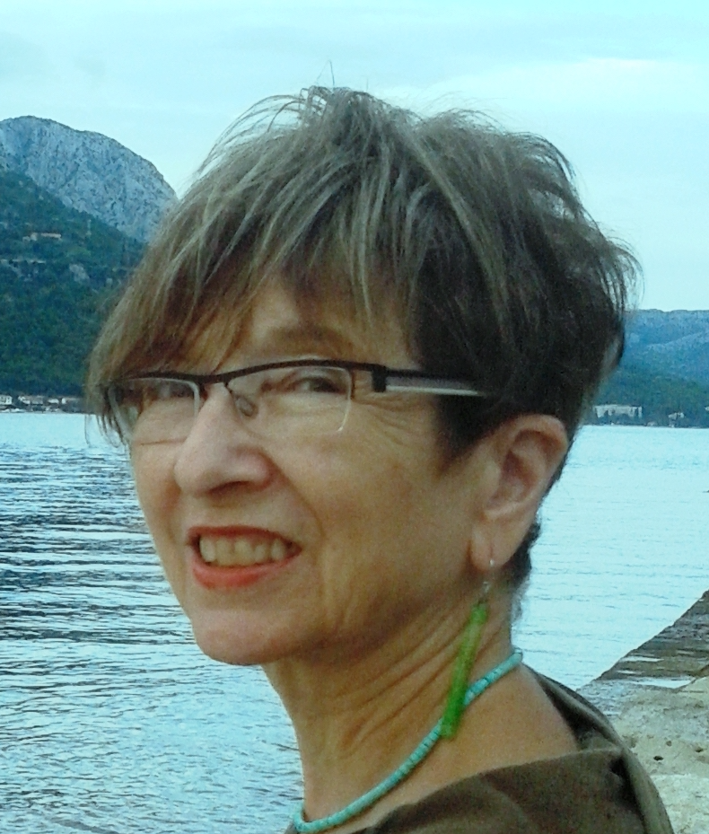
Birth | Born in Torino, May 7, 1947
Nationality | Italian
Present address  and role | Department of Life Science and Systems Biology Viale Mattioli 25 - 10125 Torino  tel. +39 011 670 5965 (office)  3493131231  E-mail: paola.bonfante@unito;  Skype paolabonfante  Full Professor of Plant Biology (till November 2017)  Currently: Professor Emerita
Education | - Italian Thesis in Biological Sciences, University of Torino (1970).  - PhD equivalent in Soil Mycology- CSMT, National Council of Research,  - Torino, ITALY (1970-1973)
Key qualifications | Research Field: Biology of Plant-Microorganism Interactions and Sustainability.  More than eighty per cent of land plants live associated to bacteria and fungi, which act as biofertilisers and bioprotectors against pathogens. They build up a plant microbiota which a crucial tool to develop new strategies for a more sustainable agriculture  Research Group coordination and main discoveries: The group she has coordinated has a research tradition on the biology of symbiotic associations, mainly mycorrhizas, and fungal taxonomy which dates back to 1975. PB spent a long part of her scientific activity studying the intimate interactions that occur between symbiotic fungi and plants as well as between bacteria and fungi, using cellular and molecular approaches. Applying DNA technologies, early in the nineties, she provided contribution to the knowledge of mycorrhizal diversity in natural as well as in cultivated fields. The main scientific missions of the group have been and still are: To understand the cellular and molecular basis of plant-fungal interactions in mycorrhizas; to investigate the genetic determinants which characterize some mycorrhizal fungi; to define the fungal biodiversity in soil; to evaluate the fungal impact in natural and agricultural ecosystems in the frame of ssustainable agriculture; to investigate the fungal interactions with other microorganisms.  In this context, in the early eighties Paola Bonfante built up an atlas of the cellular plant- fungal interactions occurring in mycorrhizal symbioses; later she has discovered two groups of endobacteria which live inside mycorrhizal fungi and - thanks to their genome sequencing- she described how these microbes may modulate some of the functional traits of their fungal hosts. These findings have pioneered a new field of research (Fungal-bacterial interactions) which is currently considered relevant in the context of the environmental microbiota. With her research group, she has discovered fungal bioactive molecules (chitooligosaccharides ) which are perceived by the host plant in order to establish the arbuscular mycorrhizal symbiosis. Such molecules are currently used to improve plant growth under in field conditions.  The expertise on cellular and molecular biology of plant/fungal interactions as well as on dynamics of fungal populations is witnessed by a large number of original, review and technical papers and multiple international collaborations.  Major scientific projects  In the more recent times, PB has devoted her attention to the beneficial impact of plant microbiota on crop plants by using omics approaches. On these issues, she has coordinated projects on: Bacterial and fungal microbiomes in rice, tomato and wheat; Dissecting the role of the fungal intracellular microbiota; Rice, tomato and whaet responses to arbuscular mycorrhizal fungi; Genomics and Functional genomics in mycorrhizal fungi; Systemic effects of mycorrhizal fungi on plant traits
Positions  Teaching positions | Professor Emerita  Full Professor of Plant Biology at the University of Torino (1984-2017)  Head of the Department of Plant Biology (October 2006-December 2011)  Responsible of the Centro di Studio sulla Micologia del Terreno del CNR- Torino, currently named Sezione di Torino dell'Istituto di Protezione per le Piante (1995-2009), Coordinator of the PhD school in Biological and Biotechnological Sciences; (2006-2013), Coordinator the PhD Course in Biology and Biotechnology of Fungi (2000-2005)  Till November 2017- Natural Sciences (Botany, Plant-Microbe interactions), Biology (Plant-Microbe interactions), Plant Biotechnology  Supervisors of hundreds of undergraduate students, and of more than 60 PhD students and postdoctoral fellows. Many of them are currently enrolled in Italian and European Universities, as well as in CNR and INRA laboratories.
Scientific  responsibilities  and general activities  Editorial  and evaluation  activities | Member of the Scientific Committee for Research Activities-Provincia di Trento (2014-2019).  Member of the Scientific Committee of CNR (2012-2016)  Member of the General Committee Compagnia di San Paolo 2020 (https://www.compagniadisanpaolo.it/it/fondazione/organi/consiglio-generale/) of the Fondazione Compagnia San Paolo Torino https://www.compagniadisanpaolo.it/it/  Organizer of many symposia, workshops and meetings on mycorrhizas and symbiotic fungi;  Visiting scientist in Japan (1989), Brazil (2012), Mexico (2016)  Invited speakers in many international congresses of Mycology, Microbiology, Botany, Biotechnology, Plant Pathology, Cell Biology, Fungal genetics, Genetics, Memorial Symposium for Biology of Symbiosis, ICOM, iMMM, Microbiota, ISME meetings  Invited seminars in many universities, worldwide  Invited to be External examiner (Opponent) for more than 20 PhD Dissertations in Europe  Member of the Scientific Committee of the Dijon Campus (France)  Member of the Scientific Committee of Plant for Future (Italy) Organizing committee of many meetings, among which MPMI Meeting in Sorrento (2007), 8th International Congress of Plant Pathology (Torino, 2008), Indian-Italian Workshop (November, 2010), IMMM (Cambridge 2015, Toulouse, 2017, Torino 2019), ISME 2016; xlvi seminario Evoluzione biologica e i grandi problemi della biologia: Il microbiota, il secondo genoma degli eucarioti  IMA Executive Committee (International Mycological Association) 2018--  Editorial and evaluation activities  Editor of Environmental Microbiology (2013-);  Senior Editor IMA FUNGUS (2019-)  Editor of Microroganisms (2019-)  Associated Editor of Fungal Biology (Till 2015); Board member of New Phytologist, Board member of IS-MPMI Interactions, The ISME Journal  Referee for papers concerning mycorrhizas for different journals (ie. Science, Nature, Plant Cell, Plant Journal, Plant Physiology, Planta, Fungal Biology & Genetics, PNAS and many others)  Evaluator for scientific European and American (NSF) Agencies. Evaluator for: ERC (Senior grants, 2011, 2019; Consolidated grants 2016), Finnish Academy, Helsinki (2018-2019); The European Science Foundation (2019-2020); MIUR (2018); CSIC Labs (Madrid, 2018)
Awards | Fellow of Academy of Sciences of Torino (2000), Academy of Agriculture of Torino (2000); Accademia dei Lincei Roma (November 2011), Académie d'Agriculture de France, Paris (2018), Accademia Europea, MAE (2019)  Award for Plant Biology 2010, Roma, June 2010  Award for the Award for the French Food Spirit- Science – Paris, December 16, 2010  2019: Appointed Commander (“Commendatore”) of the “Order of Merit of the Italian Republic” by the President of the Italian Republic (“motu proprio”).  She is in the list of:  1. Top Italian Scientists- Ranking 3 for the typology Natural sciences http://www.topitalianscientists.org/TIS_HTML/Top_Italian_Scientists_Natural_Environmental_Sciences.htm  2. Highly Quoted Researchers, (ISI) Philadelphia.http://hcr.stateofinnovation.com;  In the list of Clarivate Analytics: highly quoted researcher 2017- 2018  3. One hundred Italian Experts: http://100esperte.it/search?id=bonfante-paola-70  4. Member of Group 2003 https://www.gruppo2003.org  5. Listed as the top-rated expert in Mycorrhizae in the world by  http://www.expertscape.com/ex/mycorrhizae
Scientific production | Papers in refereed journals: 389 (listed in the official site of the University Ministry  and in the web sites of the Torino University  http://www.dbios.unito.it/do/docenti.pl/Show?_id=pbonfant#pubblicazioni  Google scholar: H index 91; citations 27000  https://scholar.google.it/citations?user=WiJOKEQAAAAJ&hl=en
Broader Science Communication | Lectures on Plant biology, Microbes, Agriculture, Food and Environments (2019-2020) for  Higher Schools in Torino, University "Terza Età"; Science Festival (Mantova 2019; Bergamo 2019); Giovedì Scienza (Torino 2020); Prepararsi al futuro (Torino, 2020)  Interview for New Phytologist 2018 https://nph.onlinelibrary.wiley.com/doi/10.1111/nph.15169  Interview for Trends in Plant science

